***Dart Loops***

1. While Loop
2. Do While Loop
3. For Loop
   1. Nested For Loop
4. ***While Loop***

**Syntax:-**

**while** (condition) {

//code to be executed

}

## Flow Diagram:-

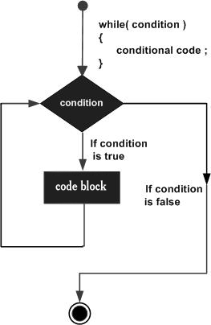

Thank You

1. ***do while Loop***

**Syntax:-**

**do** {

//code to be executed

} **while** (condition);

## Flow Diagram:-

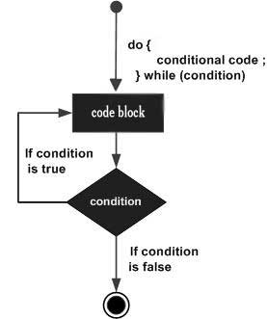

Thank You

1. ***For Loop***

**Syntax:-**

**for** (Expression 1; Expression 2; Expression 3) {

//code to be executed

}

## Flow Diagram:-

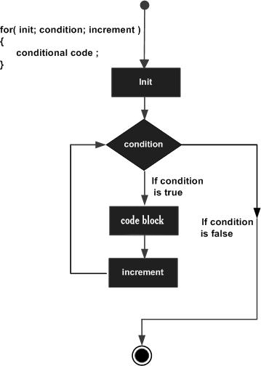

Thank You

1. ***Nested For Loop***

**Syntax:-**

**for** (Expression 1; Expression 2; Expression 3) {

**for** (Expression 1; Expression 2; Expression 3) {

//code to be executed

}

}

Thank You